AIM
Activity Customer Creation outbound
MD.120 deployment Instructions

Author: Motike Rahul Vardhan
Creation Date: June 24,2025
Last Updated:
Version: 1.0

Creating the OIC Integration for supplier Creation Outbound

Creating the connection:
- First we need the create the connection for soap and ftp before creating the oic Integration.
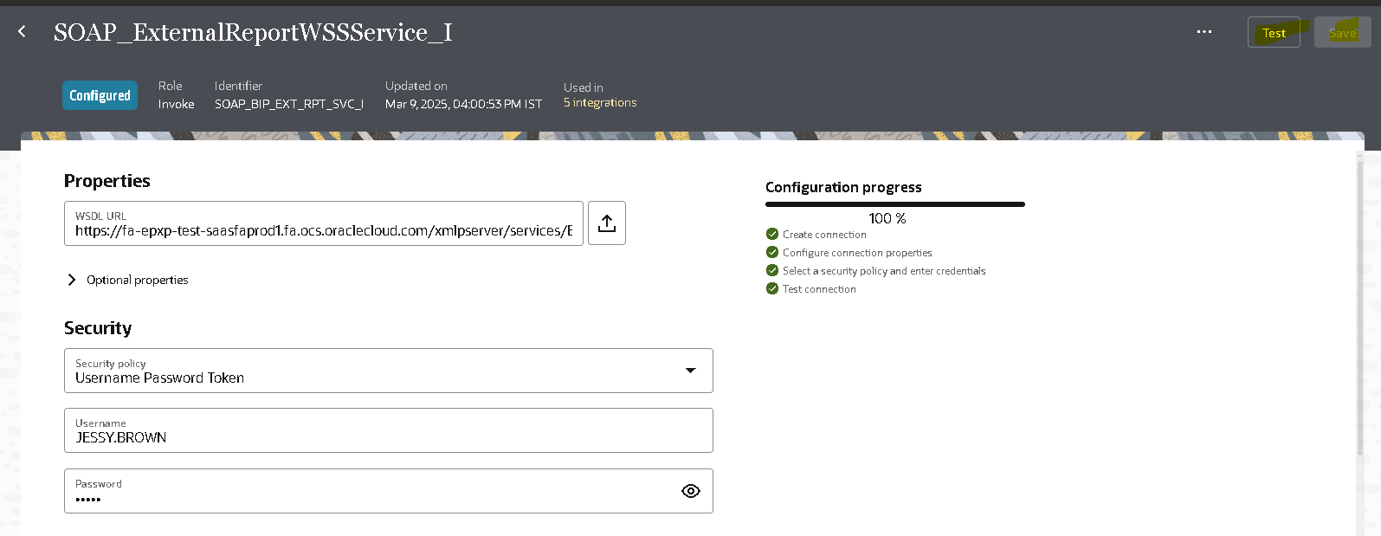
- Here we need to give the soap connection to the username,Url and password to it.
- Click on the test where if the configuration process is 100% then we can save it and use it for the connection.

- We need to create the ftp connection for it.

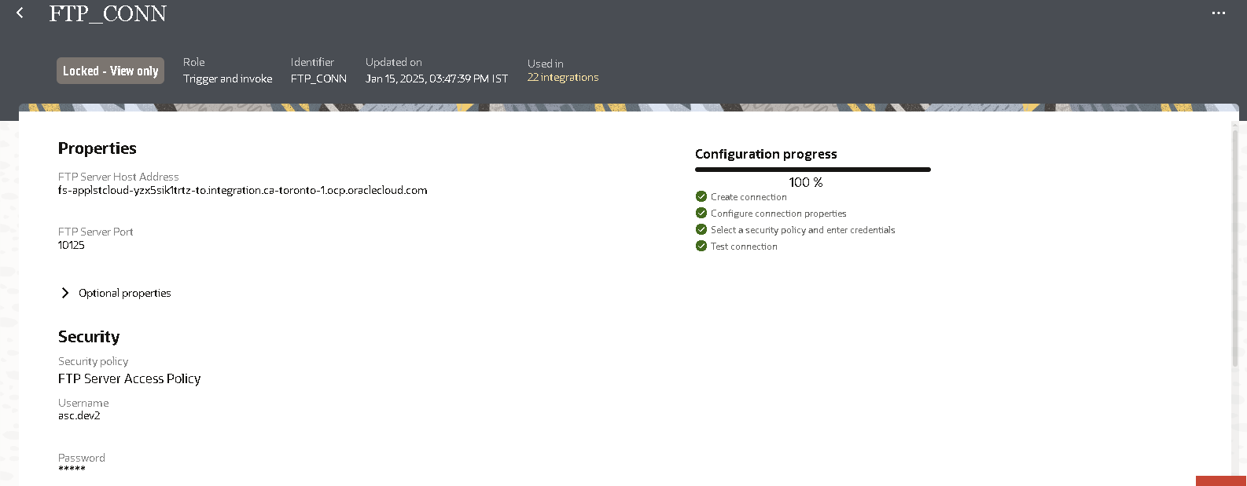
- Here we have given the ftp connection where we have configured the 100% by giving the username and password for it.

Creating the report for the Customer:
- Firstly we need write a query to get the details of the Customer for it.
- Then we need to create the data model with the query in the oracle fusion instance.
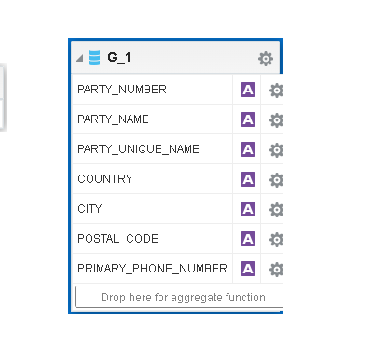
- After creation of the data model then we need to create Report for it.

Developing the Integration:
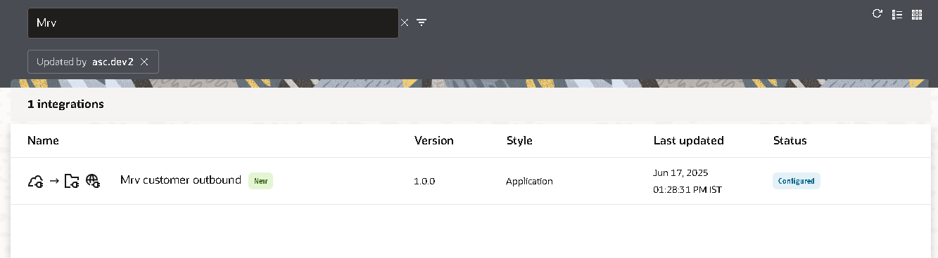
Go to the design and click on the create then select the integration process.

Here we can able to create the Rest connection for it.
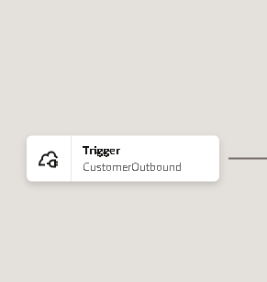

Then we need to assign the variables for it.
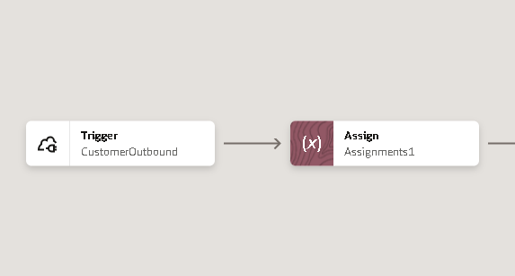
The variables are declared in the assign train.
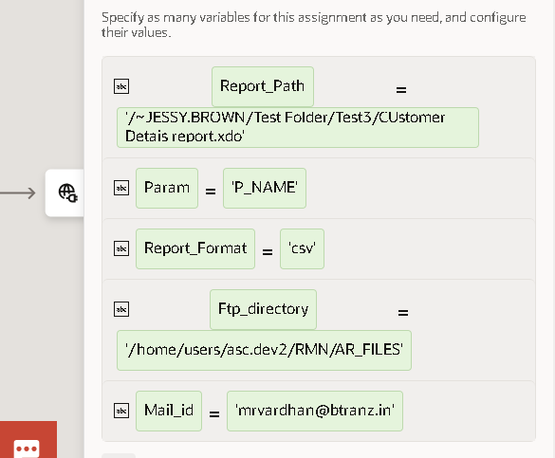
Report path : The path of the report in the oracle fusion.
The parameter consists of p_name name of the supplier
Report_format: the format is csv.
Ftp_directory: The directory of winscp(server) then we can able to delivery the csv in it.
Main_id = The mail id it is getting from.

Creating the soap connection:
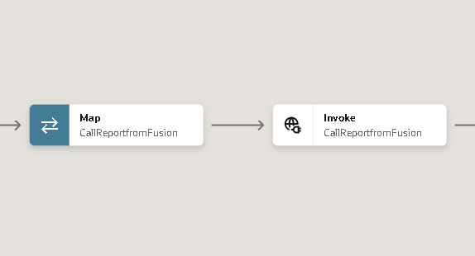
The connection for CallingtheReport to run report.
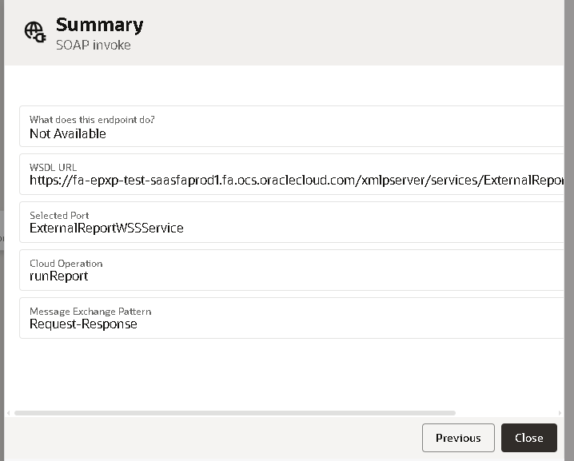
In the map we have assign the values to it.
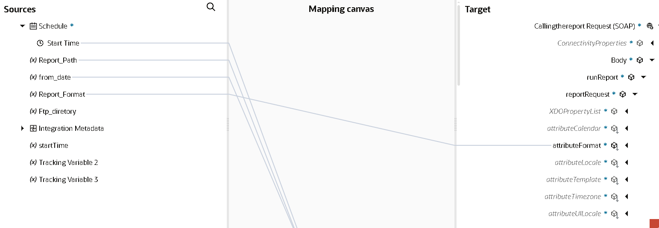

Creating the stage file to convert the format:
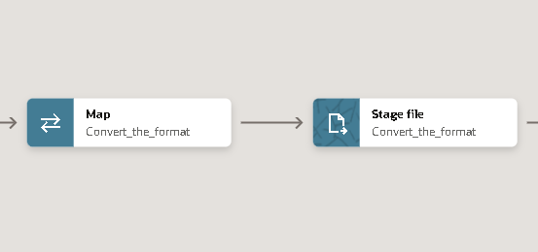
In the stage file we have created the write the file option.
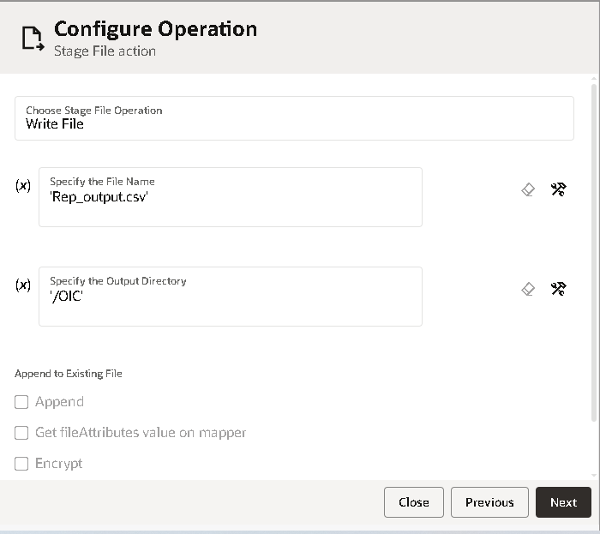
We have selected the xsd format for it.To get the file name.
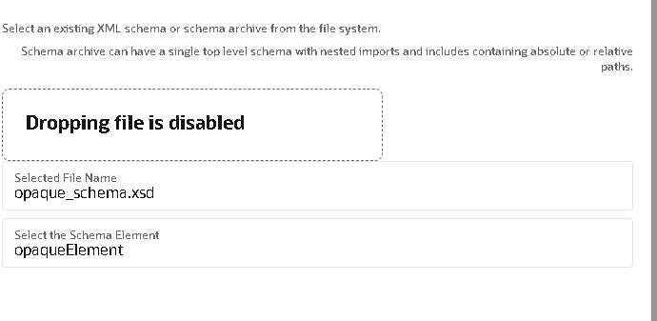
The xsd file uploaded in the file to get into it.
In the map we have mapped with the bytes to it.
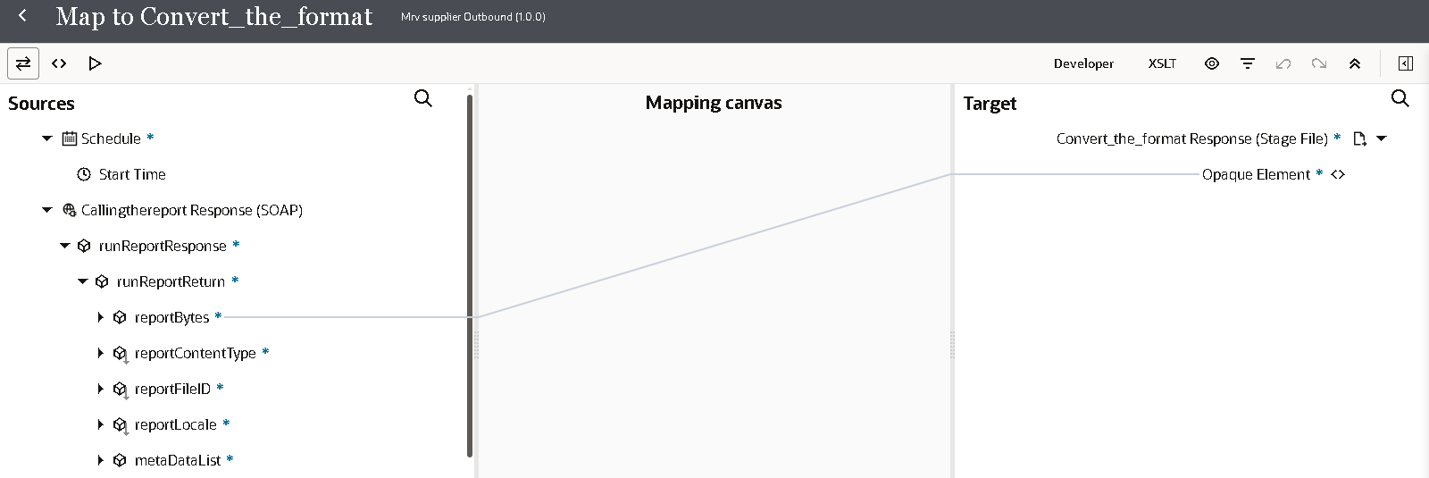

Creating the ftp connection for it:
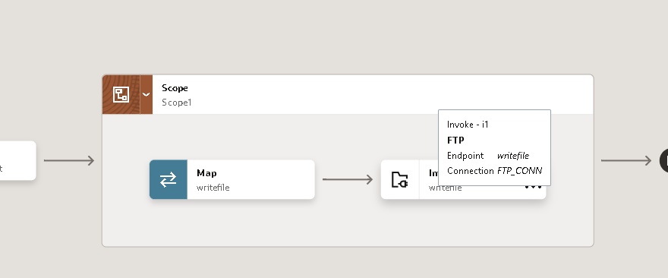
In the ftp connection I have selected the write file operation for it.
Then we need to give the output directory to save the file into it.
In the fault handler we have find the
Then we have given the file reference to it and also the properties and output directory.
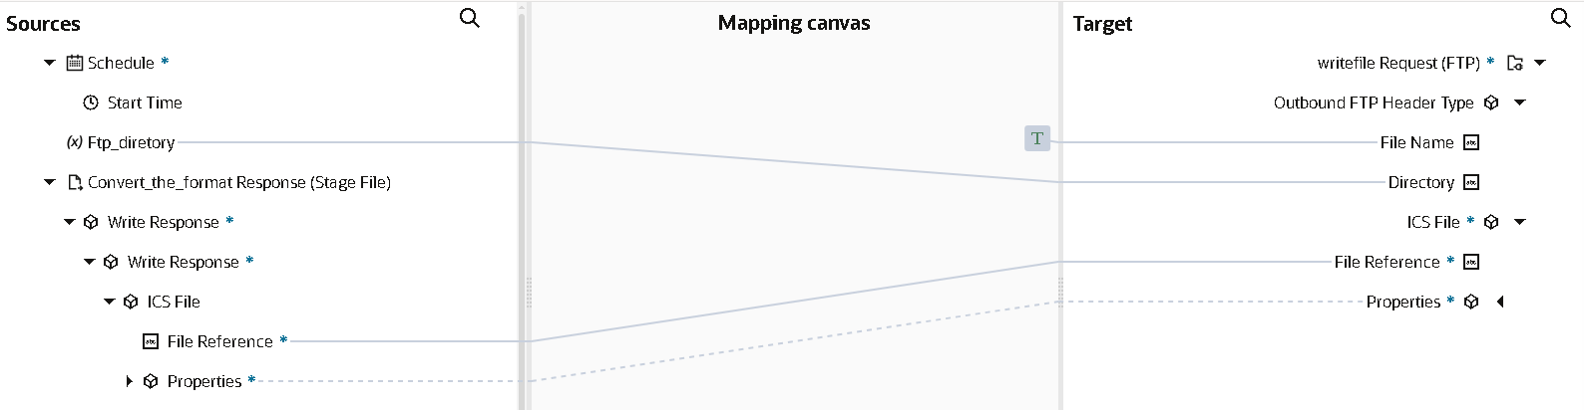
In the fault handler we have error the error will be displayed in the mail:
In the mapper we have created this no.of records as texted
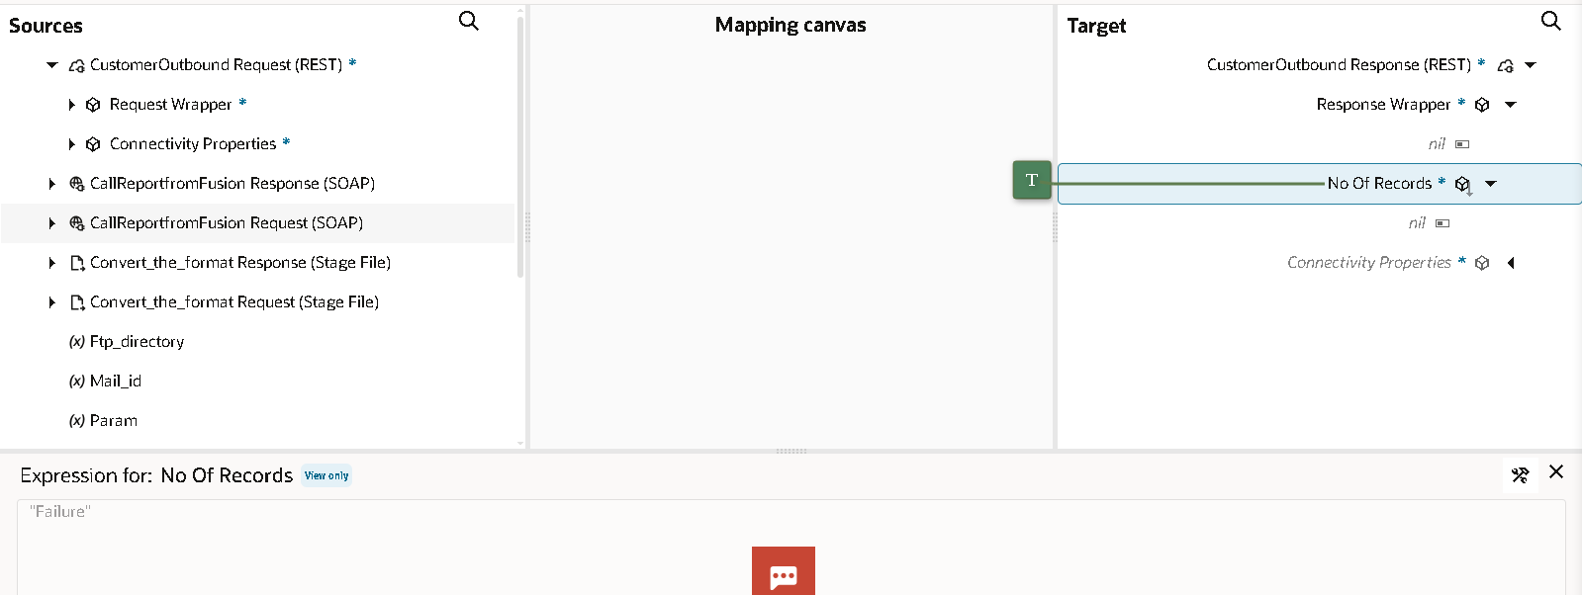

In the notification I have targeted the reason into mail.
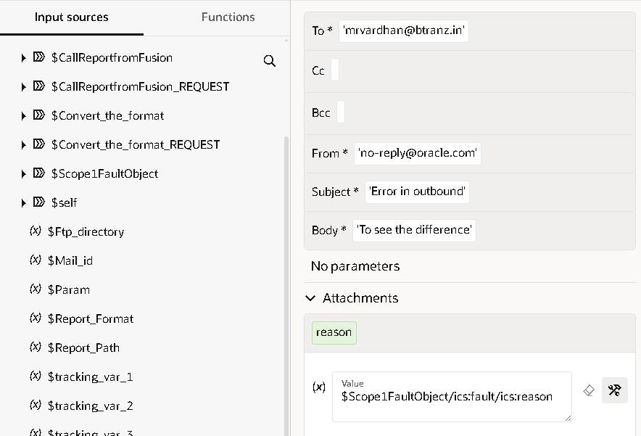
In the end the response output will be show as success
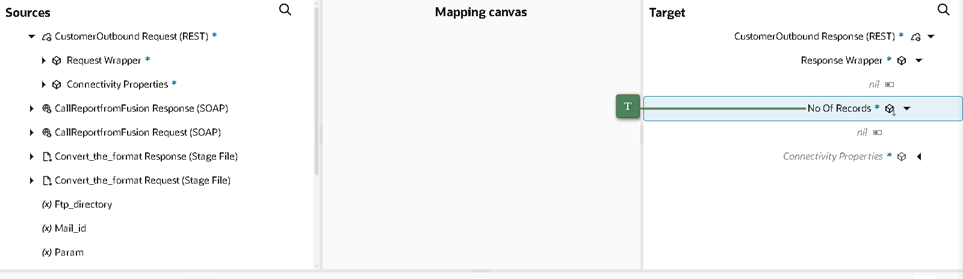

The overall integration of the supplier outbound integration:
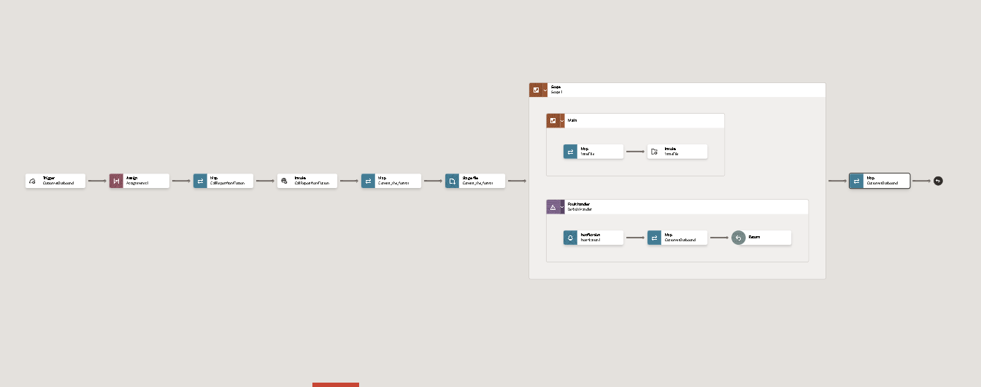

Click on the save and run the integration we can able to the get the file in the ftp server.

